e Cataract Impact Study Six Year Follow Up Summary report

The Cataract Impact Study Six Year Follow-up

Summary Report

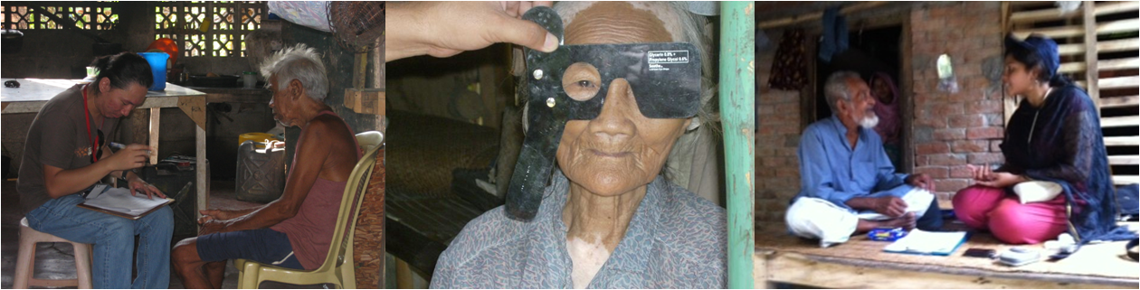

This study conducted by the International Centre for Eye Health shows the long term benefits of cataract surgery and its potential to reduce poverty.

The six year follow up study was funded by: The Fred Hollows Foundation

The original study was funded by:
CBM, Sightsavers, ORBIS

The Cataract Impact Study Six Year Follow Up

Summary
The Cataract Impact Study has shown that people in low income countries reap the benefits of cataract surgery for years after having their sight restored. Previous findings of the study showed a link between cataract surgery and an increase in family expenditure and quality of life improvements after one year. This latest release confirms that these early gains in wellbeing are maintained six years after cataract surgery and there is some evidence of improved family wealth. Cataract surgery is among the most cost-effective of health interventions and these latest findings demonstrate the potential of investing in eye health services as a strategy for long-term poverty reduction in developing countries.

Methods overview
The Cataract Impact Study was a longitudinal study involving three survey points: baseline, one year follow-up and this latest six-year follow-up. The baseline and one year follow-up were undertaken in one district in Kenya (Nakuru) and Bangladesh (Satkhira) and two regions in the Philippines (Negros Island and Antique district).

Across the three countries approximately 700 people aged ≥50 years with visual impairment from cataract (visual acuity <6/24 in the better eye) were identified in their communities. For each participant with cataract, another person of the same age and gender but without vision impairment was included as a comparison. The study participants were interviewed about their health-related quality of life, their participation in different daily activities and their household economic situation. People with cataract were offered free or subsidized surgery. After one year the study participants were re-interviewed. In Bangladesh and the Philippines a six-year follow up was also undertaken.

Findings
The original study (baseline) showed that, compared to people without vision impairment, people who had cataract in both eyes were:
- poorer in terms of asset ownership and monthly expenditure
- were more likely to need assistance and were less likely to engage in productive activities
- had poorer health-related quality of life.

However, just one year after undergoing cataract surgery, the situation for these people had improved compared to prior to surgery. By six years after cataract surgery, they were still enjoying the benefits of cataract surgery and compared to baseline they:
- had a better health-related quality of life and improved perceptions of their own health
- were more likely to be involved in productive activities such as farming, paid work and household duties;
- needed less assistance for daily activities and had improved general functioning

There were also sustained economic benefits of cataract surgery for the family including an increase in household expenditure within just one year of surgery and a longer term increase in asset ownership.

Additionally, six years after cataract surgery, these same indicators had improved to be on par with the people who hadn’t had vision impairment at the baseline. Many of the gaps in well-being and economic situation between those with cataract and those without had been closed within one year of restoring sight by cataract surgery and remained closed six years post surgery.

There was, however, some decrease in people’s activity levels and independence between the one year and six year follow-up for both the people who had cataract surgery and those who had not had vision impairment. This is most likely due to the passage of time and the typical impacts of advancing age on both groups (around half of people in the study were aged 70 years or older).
6 x

Conclusions
This study shows that for older people living in low income countries there are lasting (long-term) benefits to having sight restored by cataract surgery, including improved quality of life, increased family expenditure and the long-term accumulation of assets.

Acknowledgements
We are very grateful to:
- The Fred Hollows Foundation for funding the six year follow up of the Cataract Impact Study
- CBM, ORBIS and Sightsavers for funding the original Cataract Impact Study
- All the people in who took part in this study
- Drs Mamunur Rashid and Zakia Wadud (Bangladesh) , Cristina Eusebio (Philipinnes) and Wanjiku Mathenge (Kenya) for leading the project sites and making this research possible
- Beatrice Iezzi and Peta O’Flynn from The Fred Hollows Foundation for their input into writing this summary report

Key references:
Full study report: Danquah L, Polack S and Kuper H. The Cataract Impact Study: Six Year Follow Up Summary Report. International Centre for Eye Health, London School of Hygiene & Tropical Medicine. 2013. Available at https://www.iceh.org.uk/download/attachments/10193449/Cataract-impact-study-6-year-follow-up-summary-report.pdf?version=1&modificationDate=1386854565000
Danquah L, Kuper H, Eusebio C, Rashid MA, Bowen A, Foster A, Polack S. The Long Term Impact of Cataract Surgery on Quality of Life, Activities and Poverty: Results from a Six Year Longitudinal Study in Bangladesh and the Philippines. PLOS One 9 (4) : e94140. April 2014.
Kuper H, Polack S, Mathenge W, Eusebio C, Wadud Z, Mamunur R, Foster A. Does cataract surgery alleviate poverty? Evidence from a multi-centre intervention study conducted in Kenya, the Philippines and Bangladesh. PLoS One. 2010 Nov 9;5(11):e15431.

Polack, S, Eusebio, S., Mathenge, W., Wadud, Z., Mamunur, R., Fletcher, A., Foster, A.,
Kuper H The impact of Cataract Surgery on health related quality of life in Kenya,
Bangladesh and The Philippines. Ophthalmic Epidemiol, 2010 17(6): p.387-99.

Polack S, Eusebio C, Mathenge W, Wadud Z, Rashid M, Foster A, Kuper H The Impact of
Cataract Surgery on Activities and Time-Use: Results from a Longitudinal Study In Kenya,
Bangladesh and The Philippines PLoS ONE 2010. 5(6): p. e10913.

For further information about this study please contact:
Sarah Polack (Sarah.Polack@lshtm.ac.uk)
Lisa Danquah (Lisa.Danquah@lshtm.ac.uk)

Fast Figures: Bangladesh
Prior to cataract surgery, people affected by cataract were:
- 6 times more likely to need assistance with daily activities compared to people not affected by cataract.
- Less likely to participate in productive activities (paid work, household duties or unpaid work): 61% compared to 97% of people not affected by cataract.
- More than 3.5 times more likely to have problems with self-care.
- Poorer: monthly household per capita expenditure was nearly 50% lower compared to households not affected by cataract

In the year following cataract surgery there was a:
- 54% increase in monthly per capita expenditure among people who had surgery.
- 27% increase in the proportion of people who engaged in productive activities; rising from 61% to 88%.
The benefits of rising incomes are long-lasting:
- 6 years after cataract surgery, the gap in material assets between people who had surgery and the control group was almost entirely eliminated.

Fast Figures: The Philippines
Prior to cataract surgery, people affected by cataract:
- Were 3 times more likely to need assistance with daily activities, compared to people not affected by cataract.
- Were about 5.5 times more likely to have problems with self-care and 2.5 times more likely to have problems with daily activities.
- Poorer, with average monthly household per capita expenditure nearly $10 less per month per person compared to people not affected by cataract

In the year following cataract surgery there was a:
- 25% in monthly per capita expenditure.
- 17% increase in people regularly engaged in productive activities; rising from 80%to 94%.
The benefits of rising incomes are long-lasting:
- 6 years after cataract surgery, the gap in material assets between people who had surgery and the control group was almost entirely eliminated.

