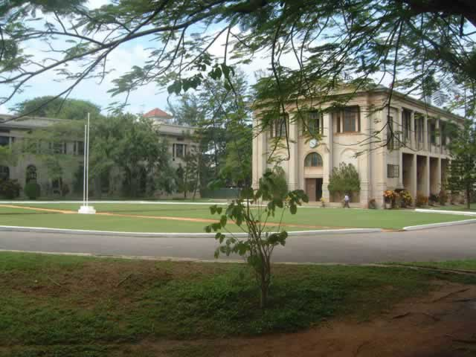
College Library & (now) Computer Centre.
S. Thomas’ College, Mount Lavinia, Sri Lanka.
http://www.stcmount.edu.lk/virtual-tour.html

