[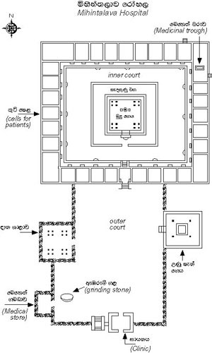](http://amazinglanka.com/wp/wp-content/uploads/2013/10/mihinthalava05.jpg)