Experience at the LSHTM Archive

As part of my masters in Archives and Record Management, I was lucky enough to gain a two week placement in the archive of the London School of Hygiene and Tropical Medicine. My task was to sort, arrange and catalogue the Bradley collection, which contains papers from a former professor of Tropical Medicine at the School. I chose the LSHTM as I wanted to see how a university archive works, especially for a subject that is completely new to me.
I come from a very non-medical background so I know very little about tropical diseases (other than catching Dengue Fever last summer) but there’s a huge amount of information in Professor Bradley’s reports and notes. I learnt so much, not just about archiving but about tropical medicine and the research carried out at the school. From malaria to AIDs, communicable viruses are ever-present, especially with the current Ebola epidemic, so it is great to see the history of something so relevant today.
David Bradley researched tropical diseases all over the world so there were a lot of documents from his visits abroad. I was particularly interested in his projects in India studying malaria as the papers were not only there reports and research on the programmes and summaries, they were itineraries, letters and emails from correspondents in Bangladesh and even flight tickets. It made me see the collection not just as amazing research on tropical diseases, but as evidence of the work behind it. Archives are a great way of gaining a background to a subject; it’s one thing to read a finished article but seeing all the previous drafts, the annotations and the notes really shows the development.
I began by sorting through the boxes and seeing what was in there to get an idea of how to arrange the contents, before moving the papers into separate files and archival boxes. I would have loved to finish the whole collection but time was catching up with me so I sorted 4 out of 8 of the boxes, before imputing the record information into Calm, the cataloguing system. By the end of my time here it was so satisfying to see the finished boxes, labelled and arranged in the archive. I also got the opportunity to experience other duties, such as helping researchers and preservation.
It was great how much freedom and responsibility the archive gave me, allowing me to try things, see if they work and amend them; vital skills needed in any job but especially in archiving! I have to thank Claire and Victoria, as well as everyone else who assisted me, for being so friendly, welcoming and helpful. The environment in the archive was lovely and I was so intrigued by the task I was given, and these contributed to a great two weeks.
Working in the LSHTM archive has made me so excited to finish my masters and begin my career in the archiving world as it’s rewarding and there’s so much to learn. It’s amazing how every day is completely different and that one career can teach you about anything.
The finished Bradley collection boxes

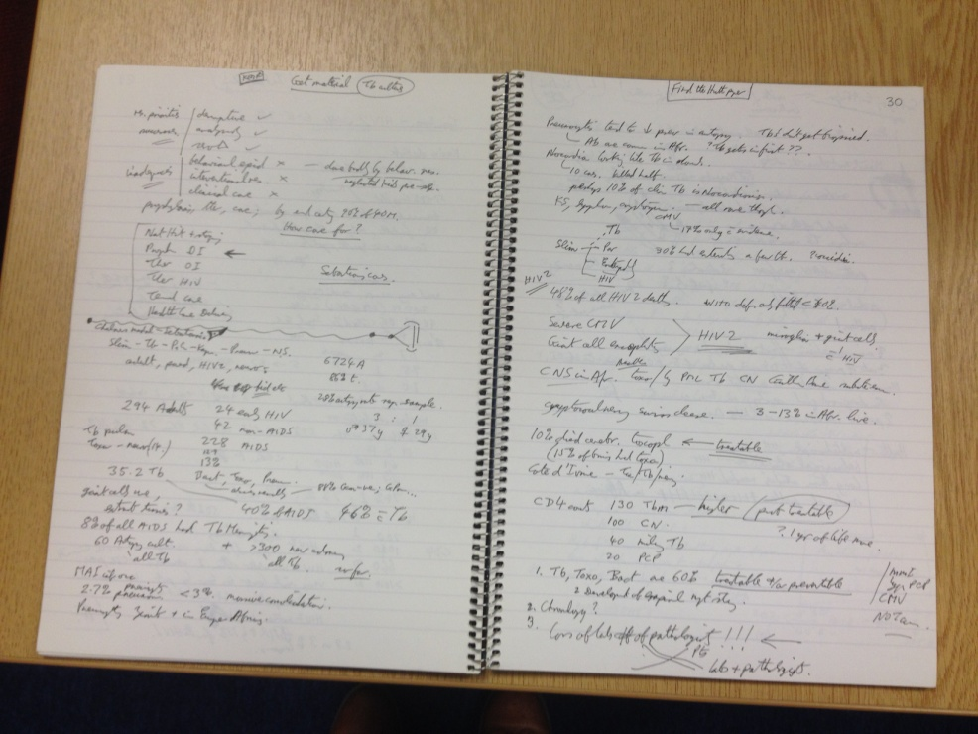
A notebook of Professor Bradley’s research

